A guide to digitally signing documents on Adobe Reader

- Open the PDF document you would like to sign
- Click the Sign icon in the toolbar. Alternatively, you can choose Tools > Fill & Sign or choose Fill & Sign from the right pane.

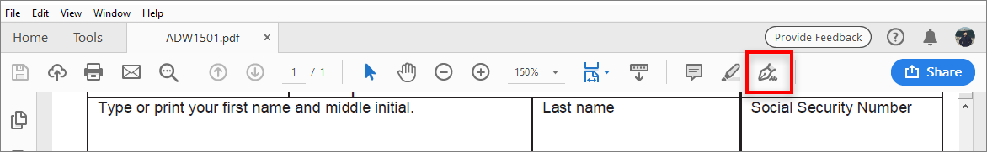

- Click Fill and Sign

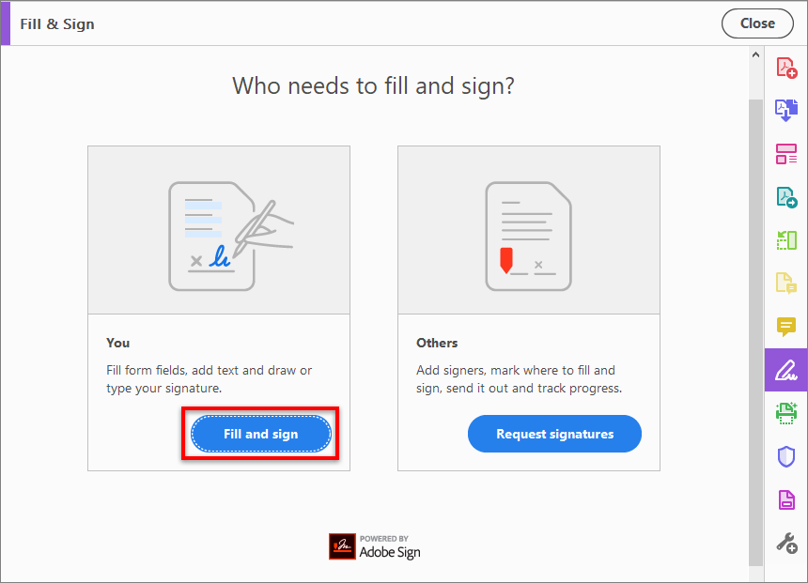

- The form fields are detected automatically. Hover the mouse over a field to display a blue box. Click anywhere in the blue box, the cursor will be placed at the right position automatically. Type your text to fill the field.

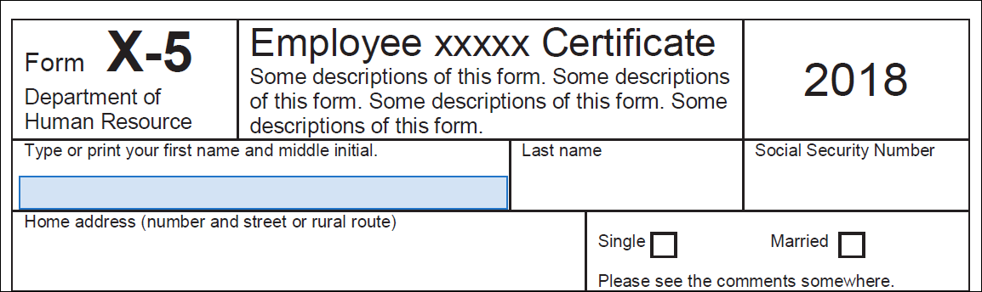

You can choose your desired color to fill the PDF form. Click the color button in the Fill & Sign menu and choose your desired color.

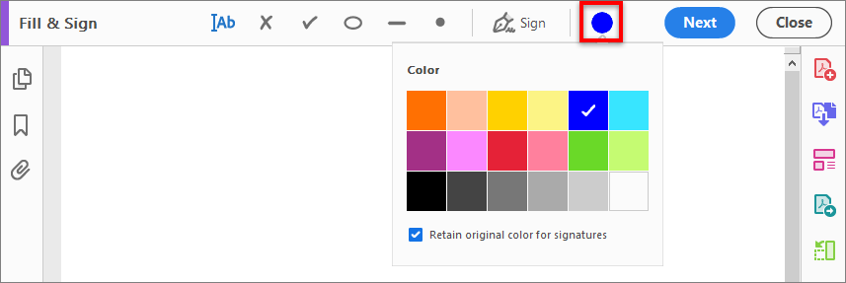

By default, the signature color is black. To retain the default color of the signature, make sure the Retain Original Color For Signature option is unchecked.

- Click the Sign icon in the toolbar, and then choose whether you want to add your signature or just initials.

- If you've already added your signature or initials, just select it from the Sign options, and then click at the place in the PDF where you want to add your signature. Skip to the next step.
If you are signing for the first time, you see the Signature or Initials panel. Below is an example of the Signature panel.

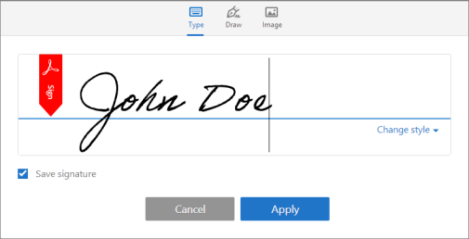

- Type: Type your name in the field. You can choose from a small selection of signature styles; click Change Style to view a different style.
- Draw: Draw your signature in the field.
- Image: Browse and select an image of your signature.
- Save Signature: When this check box is selected, and you're signed in to Acrobat Reader or Acrobat, the added signature is saved securely in Adobe Document Cloud for reuse.
Click Apply, and then click at the place in the PDF where you want to place the signature or initial.

- To move the placed signature or initial, click the field to highlight it and then use the arrow keys. To resize or delete the field, use the options in field toolbar.

